**PERTEMUAN 2**

**Laporan Praktikum - Source Code**

**NAMA : NOVIAN TRY HARTANTO**

**NPM : 4511210017**

**Source Code -** APP.JAVA

package belajar.autotes;

public class App

{

public static void main( String[] args )

{

System.out.println( "Hello World!" );

System.out.println( "hallo belajar run!" );

}

}

Apptest.java - Source code

package belajar.autotes;

import junit.framework.Test;

import junit.framework.TestCase;

import junit.framework.TestSuite;

/**

* Unit test for simple App.

*/

public class AppTest

extends TestCase

{

/**

* Create the test case

*

* @param testName name of the test case

*/

public AppTest( String testName )

{

super( testName );

}

/**

* @return the suite of tests being tested

*/

public static Test suite()

{

return new TestSuite( AppTest.class );

}

/**

* Rigourous Test :-)

*/

public void testApp()

{

assertTrue( true );

}

}

Hello test.java - Source code

package belajar.autotes;

import junit.framework.Test;

import junit.framework.TestCase;

import junit.framework.TestSuite;

/**

* Unit test for simple App.

*/

public class AppTest

extends TestCase

{

/**

* Create the test case

*

* @param testName name of the test case

*/

public AppTest( String testName )

{

super( testName );

}

/**

* @return the suite of tests being tested

*/

public static Test suite()

{

return new TestSuite( AppTest.class );

}

/**

* Rigourous Test :-)

*/

public void testApp()

{

assertTrue( true );

}

}

**PRINT SCREEN**

mvn archetype:create -DgroupId=belajar.autotes -DartifactId=belajar-autotes

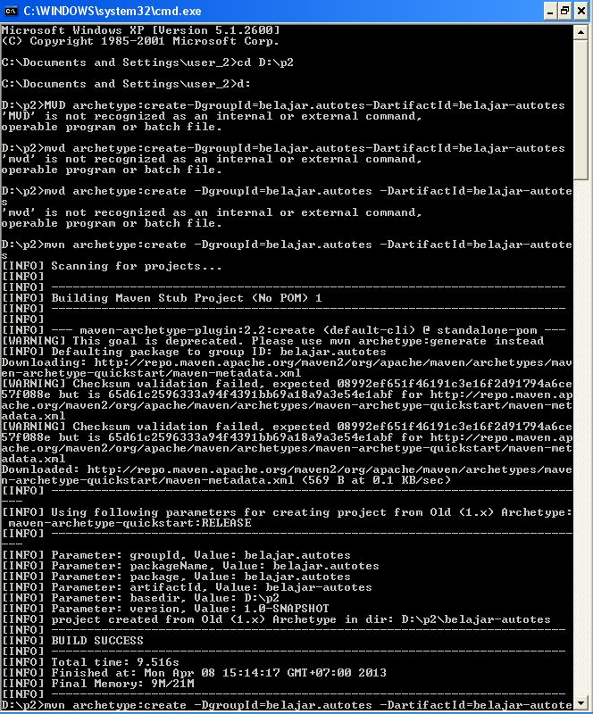

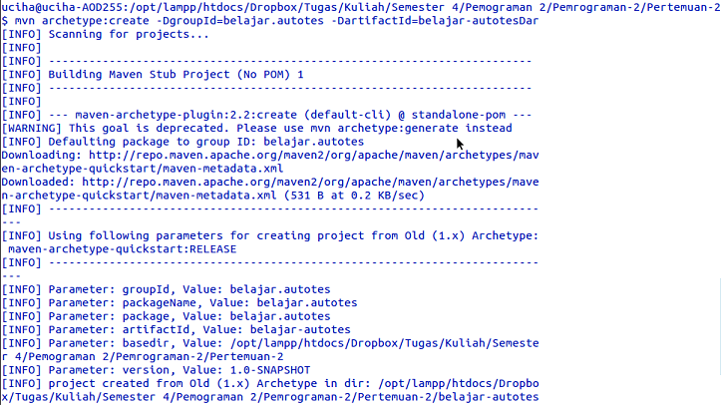

mvn clean package

